Katie ____+

Period 1

Purpose
What are the effects of the angle of the baseboard on the distance of walk-along glider flight?
Hypothesis
If the distance of glider flight is measured when changing the angle of the baseboard by increments of ten degrees, then it will fly the farthest at an angle of fifty degrees.
Research
Aerodynamics start with understanding Newton’s contributions to physics. The four forces acting on an aircraft are thrust, lift, drag, and weight. Lift pulls an air craft up, and weight brings it down. Thrust pushes an aircraft forwards, and drag pulls it back. In order to fly a level aircraft with without accelerated flight, it must have constant speed, direction, and altitude. Acceleration occurs if any of the forces change. When an aircraft climbs, its lift is greater than its weight; if an aircraft dives, its weight it greater than the lift. When an aircraft speeds up, it has a greater thrust; if its speed decreases, then the drag is greater than the thrust.
Aircrafts turn by using its wing and tail surfaces to develop aerodynamic forces. The weight and the lift contribute to turning. The sharpness of the turn is determined by the angle of the bank. ‘Bank’ is the lateral inclination of an aircraft. While turning, there is lift, the component of lift that cancels out the weight, and the component of lift that provides turning force.
Walkalong gliders use the same science as hang-gliders. Hang-gliders are unpowered aircrafts. They maintain flight by using an aerofoil, a flying surface or wing. Hang-gliders are delta wings (triangular aerofoils). They are made out of strong aluminum beams inside fabric. Unlike powered aircrafts, Hang-gliders depend on air movement to stay up and can’t take off from low ground. Instead it is launched from mountains, hills, or cliffs however, some hang gliders attach small motors or propellers so they can take off at any height.
Gravity is the main force acting on the hang-glider. The weight produces thrust and the aerofoil creates lift. If the air is still, the glider will slowly descend. It descends at a rate of about 3.6 km/h. To stay up, a pilot must find air coming up at the same rate that the glider is going down. Wind or a sea breeze can make this air.
Walkalong gliders can be made out of paper or thin foam. Paper gliders are hard to start with. In addition, humidity in the air can make the paper flimsy and difficult to work with. Since there is so much humidity in Florida, it is best to use foam. The thin foam used for gliders is made of a huge amount of petroleum and is a form of plastic. Hang-gliders stay up from wind being redirected upwards. The mountain is replaced with something large and flat and by walking with the board at a certain angle it creates a flow of air for the glider to fly on.
Some different designs of Foam gliders are the bigmouth, jaggwing, baby bug, and mama bug gliders. The bigmouth is the simplest to make and flies the slowest. The jaggwing is relatively easy to make, and flies faster than the bigmouth. The baby bug is challenging to make but efficient to fly. The mama bug is made by taping two foam sheets and is the fastest and most efficient to fly. The larger the glider, the more efficient the flight is. Other activities that advanced gliders can do are three-dimensional jousting, aerial dogfights, and flying with just one or two hands or even their head.
The walkalong foam glider kit includes two small sheets of foam, two large sheets of foam, and hair-thin nickel chromium wire. A homemade foam cutter can be made by using the chromium wire, a nine-volt battery, aluminum foil, and two forks.
Procedure
- Make 1 baby bug glider following directions from the walkalong glider kit.
- Find an open area with no drafts or wind.
- Practice gliding.
- Mark out 24ft. by putting a piece of duct tape at each foot.
- Run control flight unassisted by the baseboard.
- Gather cardboard, duct tape, protractor, and string or wire. Hold the cardboard lengthwise and fold about a quarter of it over until it is at the angle needed. When it is, take the duct tape and tape the string to each end of the cardboard.
- Double check angle with protractor.
- Stand 5ft. away from the start and begin gliding. Move board so that the folded end is parallel with the floor when passing start.
- Continue flying until it falls below knee-level.
- Record how far it goes from the tip of the glider’s nose weight.
- Repeat step 5-10 two more times each.

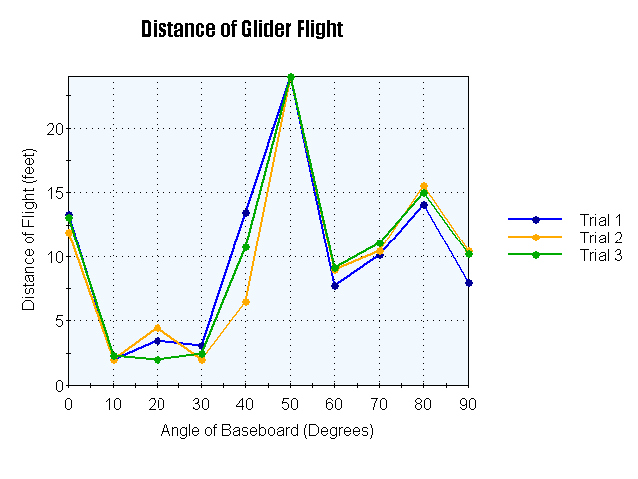

Distance of Glider Flight
Degrees | Trial 1 | Trial 2 | Trial 3
0 | 13’ 4” | 11’ 11” | 13’ 1”
10 | 2 | 2 | 2’ 4”
20 | 3’ 6” | 4’ 6” | 2
30 | 3’ 1” | 2 | 2’ 6”
40 | 13’ 6” | 6’ 6” | 10’ 9”
50 | 24 | 24 | 24
60 | 7’ 9” | 9 | 9’ 9”
70 | 10’ 2” | 10’ 5” | 11’ 1”
80 | 14’ 1” | 15’ 7” | 15
90 | 8 | 10’ 5” | 10’ 3”

Data Analysis

The glider flew the farthest at a 50 degree angle. In all three trials, the glider went past the maximum distance, which was 24 ft. The 50 degree angle was the only angle that went farther than the control all three times by over five feet. The second farthest distance was at an 80 degree angle. The ten, twenty, and thirty degree angles went the shortest distance. The graph is non-linear. The best way to fly a glider is by holding the board at a 45 to 50 degree angle.

Observations
An area was found without any drafts. The glider had to be adjusted so the glider could fly straight the whole way down the path. When it was ready for flight, the baseboard was set up. The baseboard was taped and measured with the protractor. If it needed to be changed, it was adjusted and measured again. Once it was at the right angle, the glider was launched five feet away from the start. The glider was now floating on the wave of air getting projected upwards from the baseboard.
The angles at which the glider flew the farthest on average from the greatest distance to the least are as follows:
- fifty degrees- 24’
- eighty degrees- 14’ 11”
- control (no baseboard)- 12’ 9”
- seventy and ninety degrees- 10’7”
- forty degrees- 10’ 3”
- sixty degrees- 8’ 10”
- twenty degrees- 3’ 4”
- thirty degrees- 2’ 6”
- ten degrees- 2’ 1”

Recomendations
Overall, the experiment did not have any serious complications. However, there were a couple of flaws. There was a problem with finding a place without any drafts. The area where the experiment was conducted had one small draft. Try to stay away from drafts as much as possible. If a draft happens to be in the area that the experiment, try to make the draft in a spot that won’t affect the glider as much (in the middle or the end of the track).
Another problem that arises is keeping the baseboard at the exact angle being tested. There isn’t a simple way to keep the folded cardboard parallel with the floor. To keep the experiment as accurate as possible, there should be a supervisor. The supervisor can call out adjustments to make while flying.
The third potential problem is the glider itself. Every once and a while it will need to be readjusted. If it isn’t, the glider could go off in any direction. It could also become weak or limp from too much handling. It could also rip from being handled. Try to find the fine line between being handled too little or too much.

Conclusion
The results supported the hypothesis that a fifty degree angle of the baseboard allows the glider to fly the farthest.

References
Bird, Peter A. Www.petester.com/Basic Aerodynamics. Rep. 30 May 2011. Web. <http://www.petester.com/index.htm>.
"Hang-gliders." Www.sciencelearn.org. 16 Sept. 2011. Web. <http://www.sciencelearn.org.nz/Contexts/Flight/Looking-Closer/Hang-gliders>.
Harrison, Slater. "Foam Walkalong Gliders." MAKE HOMEMADE SCIENCE TOYS AND PROJECTS. Web. 26 Oct. 2011. <http://www.sciencetoymaker.org/hangGlider/foamGliders.htm>.

